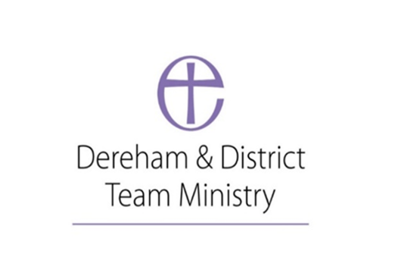
Parish of St. Nicholas Church Dereham
Church Emergency Evacuation of Building Procedure
For ticketed events
Date of first risk assessment: 11/05/2022
Time/frequency: biannually
Date to be reviewed: July 2025
- All Stewards must be briefed on how to evacuate the building in a safe and timely manner
- All doors will remain unlocked during the event (South, West, and Chancel doors)
- Prior to the event the Stewards should ensure that the steps are removed from the font to facilitate exiting through the West door
- The evacuation signal will be the sounding of the ship’s bell near the Lady Chapel.
- The person acting as host (pre-event Health and Safety talk giver) will call the emergency services if necessary
- Leave the building by the West Door if on the North Aisle and South door from the South Aisle, performers should exit via the Chancel door, and all should move to the assembly point which is in Washbridge providing these are safe exit routes.
- Do not panic. Do not collect any personal belongings and follow the instructions of the Stewards and members of the Clergy (if present)
- Stewards should sweep the building as it is evacuated to ensure all people are out.

