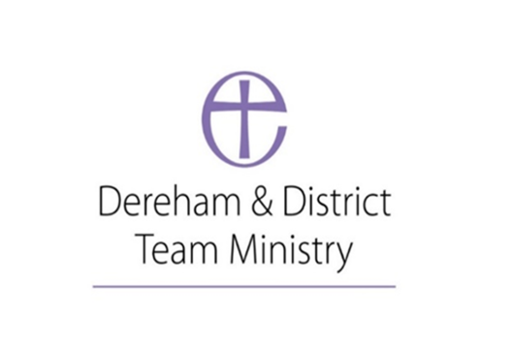
Equal Opportunities Policy
Date of first policy: July 2023 Date to be reviewed: July 2026

Dereham & District Team Ministry aims to be an equal opportunities employer and undertake to apply objective criteria to all aspects of staff recruitment and subsequent employment. Our aim is that our staff feel respected, supported and are therefore able to give of their best.
St Nicholas Parish Church, Dereham is committed to using the “Safer Recruitment” document when recruiting staff.
Our objective in the Dereham & District Team Ministry is to ensure that individuals are selected and otherwise treated solely on the basis of their relevant aptitudes, skills and abilities. We are committed to ensuring that no applicant or member of staff will receive less favourable treatment on the grounds of age, race, colour, nationality, ethnic or national origin, religion or belief, disability, gender, sexual orientation, partnership status or whether they are in part time or full time employment.
It is the policy of the Dereham & District Team Ministry not to discriminate against disabled persons whether in, or applying for, employment. Appointments of disabled people will be made on the same terms and conditions as other comparable employees without disabilities.
If staff develop a serious health condition, and become disabled physically or mentally, they should advise their line manager of any reasonable adjustments needed to their working conditions or to the nature of their job which they believe could assist them in the performance of their duties.

This policy was adopted by xxxx Parish Church PCC on ……………………

Signed by the Rector/Team Vicar …………………………………………………………………

