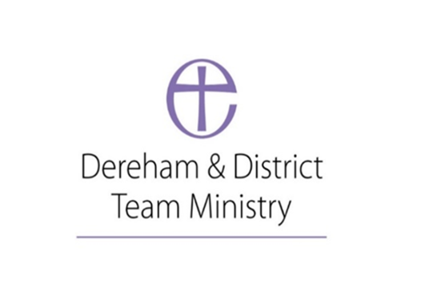
Parish of St. Nicholas Church Dereham
Safer Recruitment Policy
Date of first policy: July 2023 Date to be reviewed: July 2026

St Nicholas Church, Dereham is committed to the safeguarding and protection of all children, young people and adults, and the care and nurture of children within our church communities.
We will carefully select, train and support all those with any responsibility within the Church, in line with Safer Recruitment principles.

This means that we will:

• Ensure that our recruitment and selection processes are inclusive, fair, consistent and transparent.
• Take all reasonable steps to prevent those who might harm children or adults from taking up positions of respect, responsibility or authority where they are trusted by others.
• Adhere to safer recruitment legislation, guidance and standards, responding positively to changing understandings of good safer recruitment practice.
• Use the guidance detailed in The Parish Safeguarding Handbook (2019) Chapter 5
www.dioceseofnorwich.org/wp-content/uploads/2019/08/Parish_Safeguarding_Handbook_March_2019.pdf
• Always seek advice from Diocesan Safeguarding Team to achieve best possible practice.
• All those responsible for appointing or recruiting personnel should ensure they have training in Safer Recruitment Practice.
• Introduce systems for monitoring adherence to the Churches’ safer recruitment practice guidance and review them regularly. (Parish Safeguarding Dashboard)

This policy was adopted by Dereham Parish Church PCC on ……………………

Signed by the Priest-in-charge …………………………………………………………………

